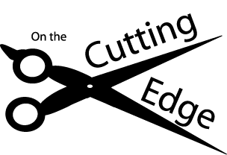

THE CUTTING EDGE HAIR SALON
12345 MELROSE AVENUE
BEVERLY HILLS, CA 90210
(310) 897-6543

Megan Ortiz
My Tran
Period 6
December 9, 2013

